Sales Analytics Pipeline
Phase 2 — Data Modeling (ERD)
Entity relationships and key reference across Bronze, Silver, Gold, and Export layers
Prepared by: Jerry Wyatt
Date: August 14, 2026
Revision: v3 — CUSTOM_ACTIVITIES is replaced by CUSTOM_ACTIVITY_TYPES + CUSTOM_ACTIVITY_FIELDS after reviewing the project's explanation video and GoodNotes transcript; see Sections 4.1, 4.2, 7
Status: Draft — pending SME review and sign-off before Phase 3
Builds on: Phase 1 — Architecture Design (v3)

1. Purpose & Scope
This document completes the Phase 2 deliverable: a full entity relationship model for the Sales Analytics Pipeline, covering Bronze, Silver, Gold, and Export. It builds directly on the Phase 1 architecture (table/view names and layer design) and the provided Snowflake Data Architecture Model, and incorporates the leads_raw decision confirmed with the SME: leads_raw is ingested to Bronze, with Silver/Gold modeling deferred until a report requires it.
Two diagrams are provided: a formal entity relationship diagram for the Silver layer (primary keys, foreign keys, and cardinality — the layer where real relational structure exists), and a source-to-report lineage diagram for Gold and Export (which are business-logic views and materialized aggregates, not physically keyed tables). Both are followed by a written table/key reference so every relationship shown visually is also stated explicitly.

2. How to Read This ERD
- PK (primary key) — the column, or combination of columns, that uniquely identifies a row in that table.
- FK (foreign key) — a column whose value should correspond to a PK in another table. An arrow label of "(deferred)" means the source column exists but the target entity is not yet modeled in Silver.
- Cardinality (1, N, 0..1) — read from the entity nearest the label toward the other end, e.g. CLOSE_CRM_USERS_PROCESSED "1" to LEAD_ACTIVITIES_PROCESSED "N" means one user is linked to many activities.
- Bronze tables and Gold/Export objects are not part of the formal ERD because they are not relationally keyed: Bronze is an unstructured JSON landing zone, and Gold/Export are views and aggregates derived by filtering and joining Silver. Both are still documented with grain and lineage below.

3. Bronze Layer Entities
Bronze tables carry no primary key — every row is a raw JSON payload plus a load timestamp, and the same logical record can appear many times across daily batches. Grain is per-file-record-per-load, not per-business-entity.
Bronze Table | Grain | Feeds
LEAD_ACTIVITIES_RAW | 1 row per activity record per daily load | LEAD_ACTIVITIES_PROCESSED_TRANSIENT
CUSTOM_ACTIVITIES_RAW | 1 row per activity-type-definition record per daily load | CUSTOM_ACTIVITIES_TRANSIENT -> CUSTOM_ACTIVITY_TYPES, CUSTOM_ACTIVITY_FIELDS
CLOSE_CRM_USERS_RAW | 1 row per user record per daily load | CLOSE_CRM_USERS_PROCESSED
LEADS_RAW (added, Phase 1 Sec. 4.1) | 1 row per lead record per daily load | None yet — landed for future use, not modeled further in this phase

4. Silver Layer — Entities & Relationships
The Silver layer is where the pipeline first has real relational structure: deduplicated, typed tables with primary keys, joined by shared business identifiers.
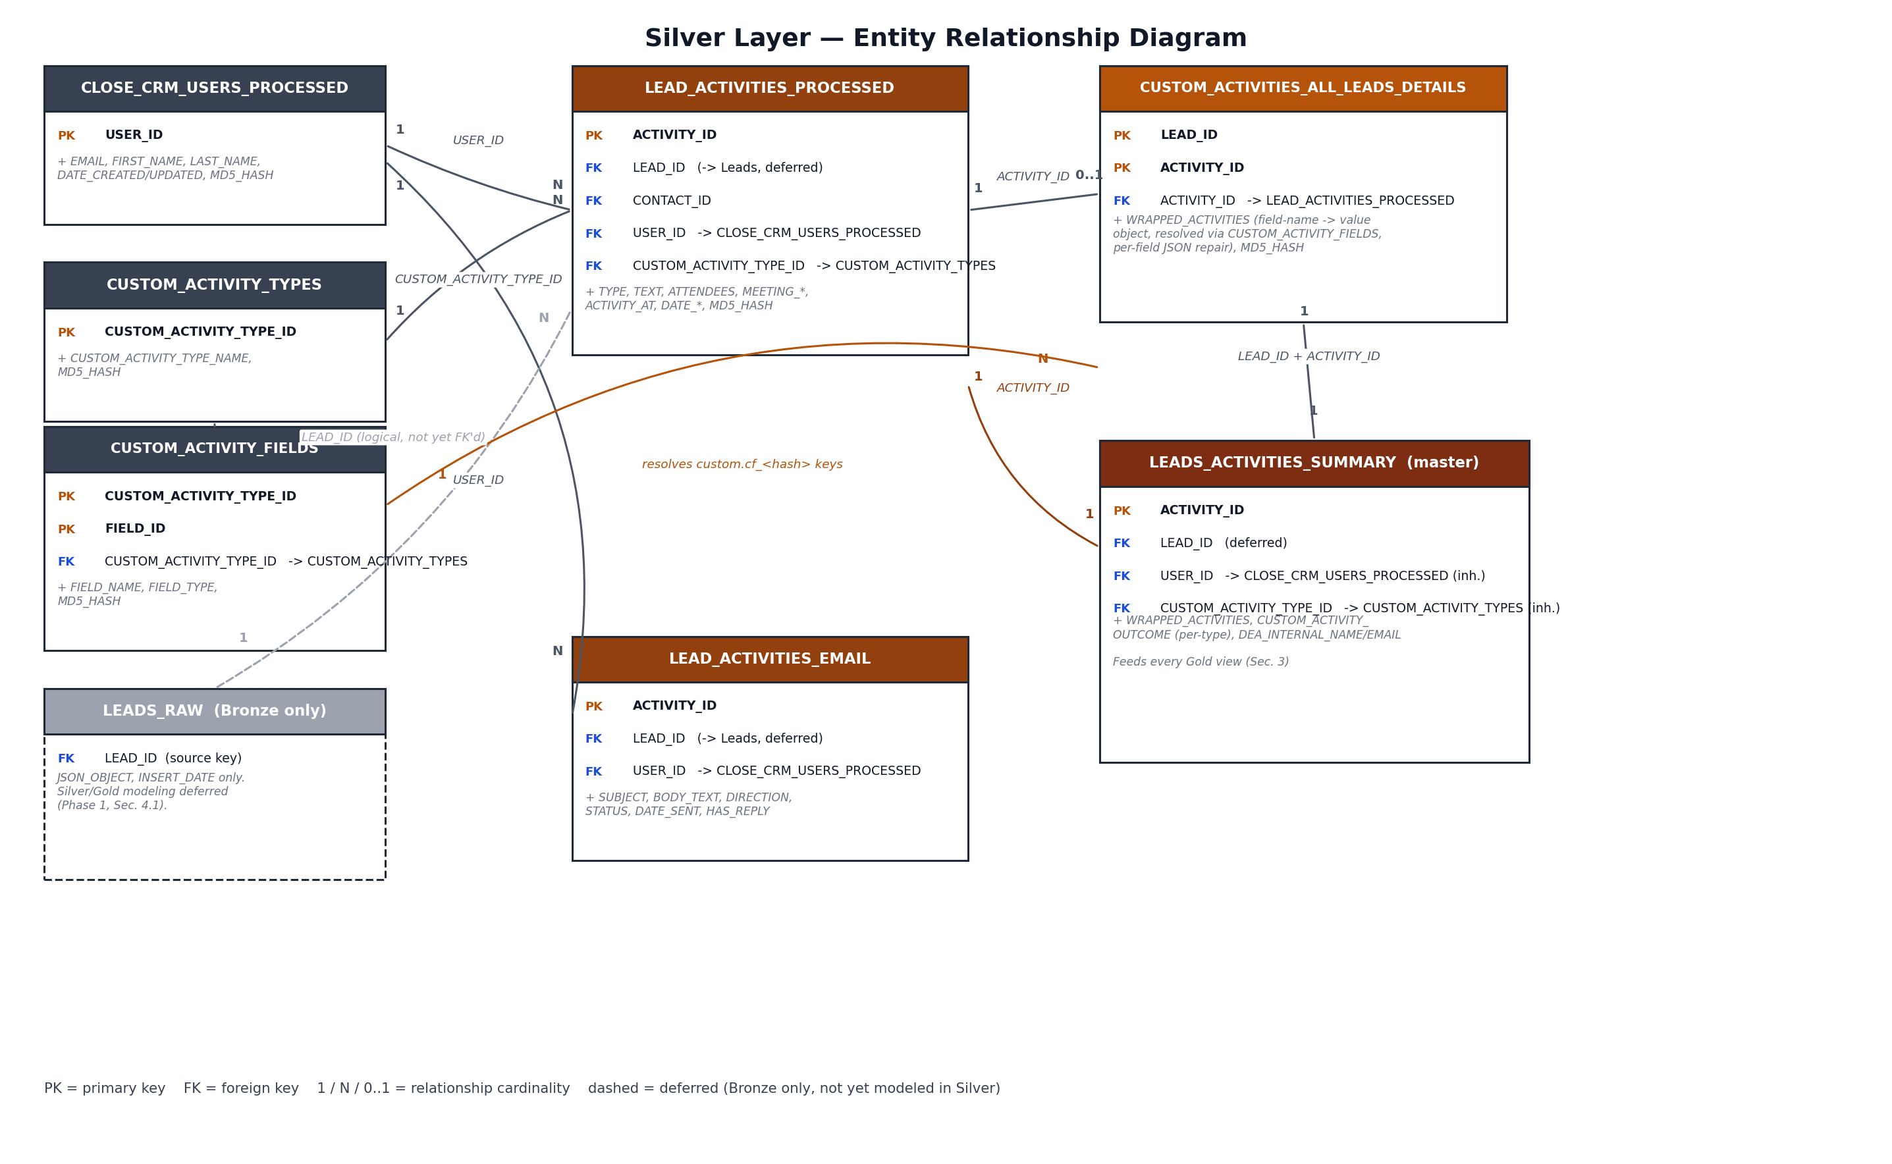
Figure 1. Silver layer entity relationship diagram (v3 — two-level custom activity dictionary).
Revised from v2: CUSTOM_ACTIVITIES (a flat outcome dictionary) is replaced by CUSTOM_ACTIVITY_TYPES and CUSTOM_ACTIVITY_FIELDS. This follows from reviewing the project's explanation video and GoodNotes transcript, which showed that custom field values on an activity are keyed by an opaque custom.cf_<hash> ID, and that ID only resolves to a name via a per-activity-type field list in custom_activites_raw — a two-level dictionary, not the one-level outcome lookup originally modeled.

4.1 Entity Reference
Entity | Primary Key | Foreign Keys | Grain
CLOSE_CRM_USERS_PROCESSED | USER_ID | — | 1 row per CRM user
CUSTOM_ACTIVITY_TYPES | CUSTOM_ACTIVITY_TYPE_ID | — | 1 row per custom activity type (Triage Call, Strategy Call, ...)
CUSTOM_ACTIVITY_FIELDS | CUSTOM_ACTIVITY_TYPE_ID + FIELD_ID | CUSTOM_ACTIVITY_TYPE_ID -> CUSTOM_ACTIVITY_TYPES | 1 row per field defined on a custom activity type
LEAD_ACTIVITIES_PROCESSED | ACTIVITY_ID | USER_ID -> CLOSE_CRM_USERS_PROCESSED; CUSTOM_ACTIVITY_TYPE_ID -> CUSTOM_ACTIVITY_TYPES; LEAD_ID, CONTACT_ID (deferred) | 1 row per deduplicated activity
LEAD_ACTIVITIES_EMAIL | ACTIVITY_ID | USER_ID -> CLOSE_CRM_USERS_PROCESSED; LEAD_ID (deferred) | 1 row per email/SMS activity
CUSTOM_ACTIVITIES_ALL_LEADS_DETAILS | LEAD_ID + ACTIVITY_ID | ACTIVITY_ID -> LEAD_ACTIVITIES_PROCESSED; resolved per-field via CUSTOM_ACTIVITY_FIELDS | 1 row per lead's custom activity
LEADS_ACTIVITIES_SUMMARY | ACTIVITY_ID | USER_ID -> CLOSE_CRM_USERS_PROCESSED; CUSTOM_ACTIVITY_TYPE_ID -> CUSTOM_ACTIVITY_TYPES; LEAD_ID (deferred) | 1 row per activity, fully resolved (master table)

4.2 Relationship Reference
From | To | Join Key | Cardinality | Notes
CLOSE_CRM_USERS_PROCESSED | LEAD_ACTIVITIES_PROCESSED | USER_ID | 1 : N | One user performs many activities
CLOSE_CRM_USERS_PROCESSED | LEAD_ACTIVITIES_EMAIL | USER_ID | 1 : N
CUSTOM_ACTIVITY_TYPES | LEAD_ACTIVITIES_PROCESSED | CUSTOM_ACTIVITY_TYPE_ID | 1 : N | Populated only where TYPE = CustomActivity
CUSTOM_ACTIVITY_TYPES | CUSTOM_ACTIVITY_FIELDS | CUSTOM_ACTIVITY_TYPE_ID | 1 : N | Each type defines its own field list
CUSTOM_ACTIVITY_FIELDS | CUSTOM_ACTIVITIES_ALL_LEADS_DETAILS | CUSTOM_ACTIVITY_TYPE_ID + FIELD_ID | 1 : N | Logical, not a stored FK — used to resolve custom.cf_<hash> keys into WRAPPED_ACTIVITIES
LEAD_ACTIVITIES_PROCESSED | CUSTOM_ACTIVITIES_ALL_LEADS_DETAILS | ACTIVITY_ID | 1 : 0..1 | Only custom activities carry wrapped fields
LEAD_ACTIVITIES_PROCESSED | LEADS_ACTIVITIES_SUMMARY | ACTIVITY_ID | 1 : 1 | Enriched version of the same activity row
CUSTOM_ACTIVITIES_ALL_LEADS_DETAILS | LEADS_ACTIVITIES_SUMMARY | LEAD_ID + ACTIVITY_ID | 1 : 1
LEADS_RAW (Bronze) | LEAD_ACTIVITIES_PROCESSED / LEADS_ACTIVITIES_SUMMARY | LEAD_ID | 1 : N (logical) | Not an enforced constraint — deferred per Phase 1 decision

5. Gold Layer — Views & Lineage
Gold views are not physically keyed tables; each is a filtered, joined read of LEADS_ACTIVITIES_SUMMARY (plus CUSTOM_ACTIVITY_TYPES for activity-type text and CLOSE_CRM_USERS_PROCESSED for setter/closer identity), scoped to one stage of the funnel. The diagram below shows lineage — what each view is built from — rather than primary/foreign key pairs. Setter/Closer on ALL_STRATEGIES_DETAILS and SALES_DETAILS now resolve primarily from that activity's own Setter/Closer custom fields (via CLOSE_CRM_USERS_PROCESSED), not only by looking back at the booking view (Phase 3 deviation, see runbook Section 8).
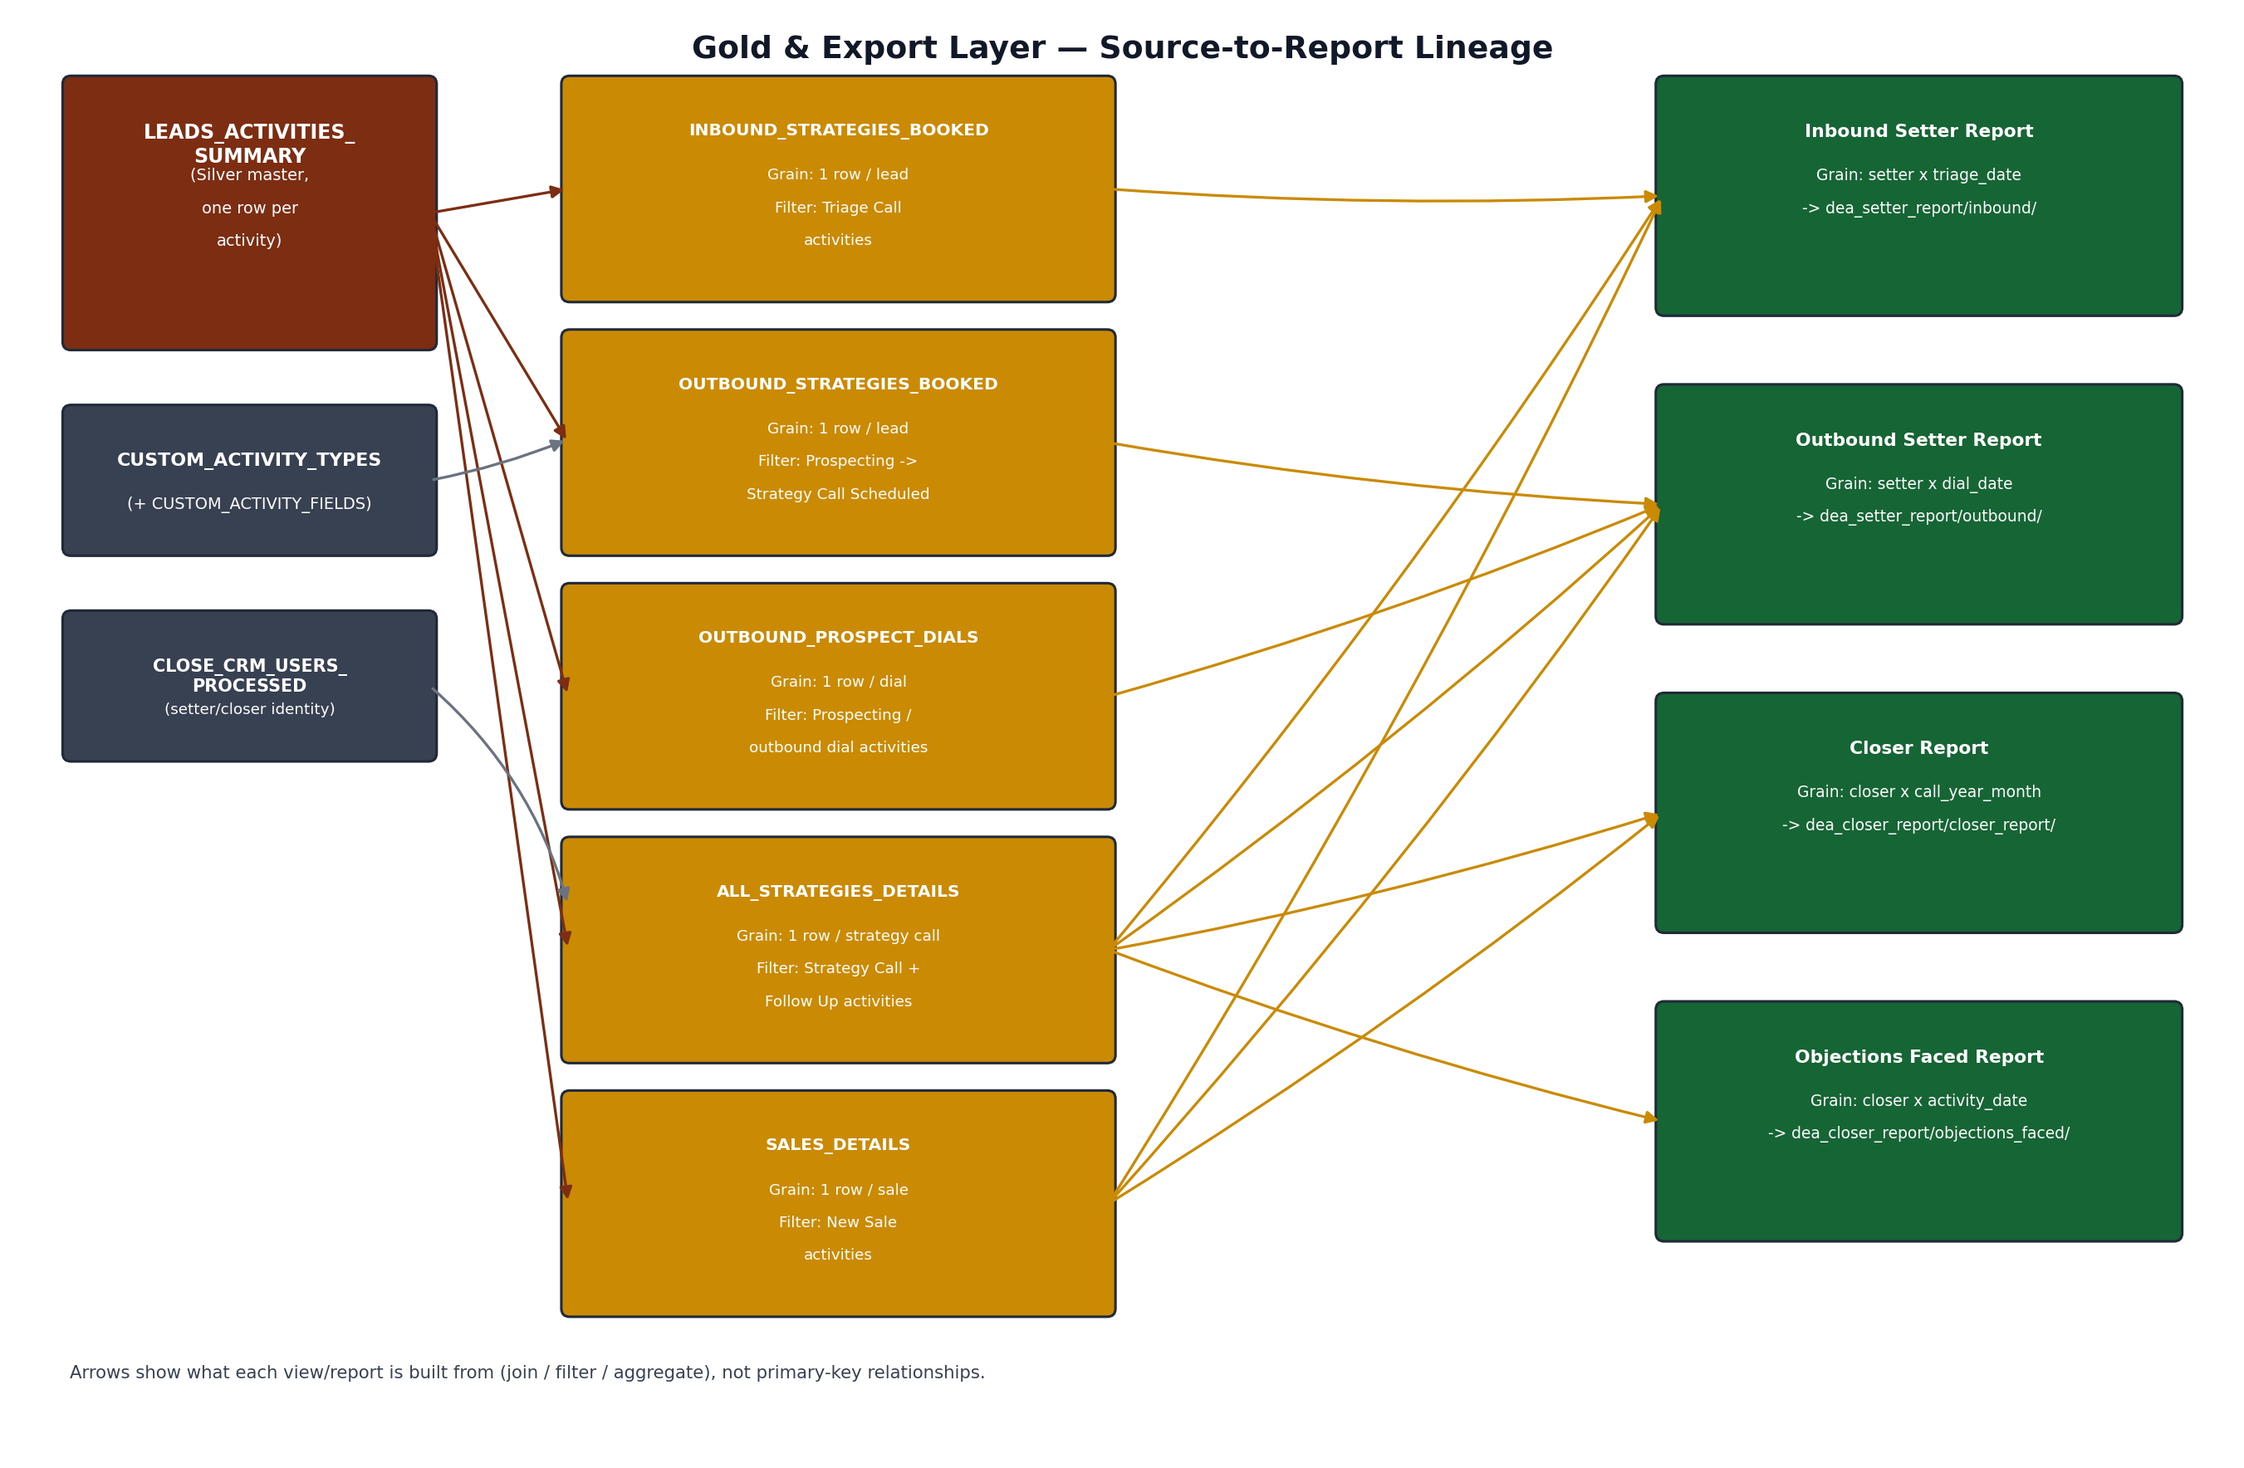
Figure 2. Gold and Export layer source-to-report lineage.

5.1 Gold View Reference
View | Grain | Filter / Business Rule
INBOUND_STRATEGIES_BOOKED | 1 row per lead (inbound path) | Triage Call activities; STRATEGY_CALL_BOOKED = outcome '1. Strategy Call Scheduled'
OUTBOUND_STRATEGIES_BOOKED | 1 row per lead (outbound path) | Prospecting/outbound call activities; outcome '2. Strategy Call Scheduled'
OUTBOUND_PROSPECT_DIALS | 1 row per dial activity | All prospecting/outbound dial activities regardless of outcome (top-of-funnel volume)
ALL_STRATEGIES_DETAILS | 1 row per strategy call activity | Strategy Call + Strategy Call Follow Up activities; excludes no-show/cancel from Show metrics; OFFER_PRESENTED derived
SALES_DETAILS | 1 row per sale activity | New Sale activities where a prior attended Strategy Call exists for the same lead

6. Export Layer — Report Reference
Report | Grain | Built From | Target Stage
Inbound Setter Report | setter x triage_date | INBOUND_STRATEGIES_BOOKED, ALL_STRATEGIES_DETAILS, SALES_DETAILS | dea_setter_report/inbound/
Outbound Setter Report | setter x dial_date | OUTBOUND_PROSPECT_DIALS, OUTBOUND_STRATEGIES_BOOKED, ALL_STRATEGIES_DETAILS, SALES_DETAILS | dea_setter_report/outbound/
Closer Report | closer x call_year_month | ALL_STRATEGIES_DETAILS, SALES_DETAILS | dea_closer_report/closer_report/
Objections Faced Report | closer x activity_date | ALL_STRATEGIES_DETAILS (objection fields) | dea_closer_report/objections_faced/

7. Cross-Layer Key Reference
A single reference for the four identifiers used throughout the model:
Key | Originates In | Used By | Notes
LEAD_ID | leads_raw / lead_activities payload | LEAD_ACTIVITIES_PROCESSED, LEAD_ACTIVITIES_EMAIL, CUSTOM_ACTIVITIES_ALL_LEADS_DETAILS, LEADS_ACTIVITIES_SUMMARY, all Gold views | No Silver LEADS entity yet; treated as an attribute, not an enforced FK, until leads_raw is modeled (Sec. 8)
ACTIVITY_ID | lead_activities_raw payload | LEAD_ACTIVITIES_PROCESSED (PK), CUSTOM_ACTIVITIES_ALL_LEADS_DETAILS, LEADS_ACTIVITIES_SUMMARY (PK) | Deduplicated with LEAD_ID via MD5_HASH + keep-latest ACTIVITY_AT (Phase 1, Sec. 5.5)
USER_ID | close_crm_users_raw payload | CLOSE_CRM_USERS_PROCESSED (PK), LEAD_ACTIVITIES_PROCESSED, LEAD_ACTIVITIES_EMAIL, LEADS_ACTIVITIES_SUMMARY | Setter vs. closer role is resolved per Gold view, not stored as a static attribute
CUSTOM_ACTIVITY_TYPE_ID | custom_activites_raw payload (top-level id) | CUSTOM_ACTIVITY_TYPES (PK), CUSTOM_ACTIVITY_FIELDS (PK part), LEAD_ACTIVITIES_PROCESSED, LEADS_ACTIVITIES_SUMMARY | Identifies the activity type (Triage Call, Strategy Call, ...); no longer paired with an OUTCOME_ID
FIELD_ID (custom.cf_<hash>) | custom_activites_raw payload (nested fields[].id) | CUSTOM_ACTIVITY_FIELDS (PK part); matched against each custom.cf_<hash> key on an activity record | Opaque, Close-generated; only meaningful when resolved per CUSTOM_ACTIVITY_TYPE_ID (Sec. 4.1)

8. Open Items for SME Review
- Confirm whether ACTIVITY_ID is globally unique or only unique within a LEAD_ID. The Phase 1 dedup logic keys on LEAD_ID + ACTIVITY_ID, while LEAD_ACTIVITIES_PROCESSED and LEADS_ACTIVITIES_SUMMARY are modeled here with ACTIVITY_ID alone as PK — these should agree before Phase 3 implements the MERGE statements.
- CONTACT_ID appears on LEAD_ACTIVITIES_PROCESSED but there is no CONTACTS entity in the current model. Confirm whether contact-level detail is needed for any of the four reports or can remain unmodeled, consistent with the leads_raw deferral.
- Resolved (v3): CUSTOM_ACTIVITIES is replaced by CUSTOM_ACTIVITY_TYPES + CUSTOM_ACTIVITY_FIELDS, confirmed against the explanation video/transcript. Still open: confirm the field-ID -> field-name mapping is stable over time per activity type (i.e. Close doesn't reuse a cf_<hash> for a different field on the same type later), since CUSTOM_ACTIVITY_FIELDS is upserted by (type, field) key.
- Confirm LEAD_ACTIVITIES_PROCESSED to LEADS_ACTIVITIES_SUMMARY is strictly 1:1 (every processed activity gets a summary row) rather than filtered to a subset of activity types.
- Once leads_raw is modeled beyond Bronze, revisit LEAD_ID everywhere in this ERD as a proper enforced foreign key rather than a shared attribute.

9. Next Steps
- Phase 3 — Build the pipeline: Bronze COPY INTO, Silver repair/FLATTEN/MERGE (including the JSON repair UDF and MD5_HASH dedup), Gold view SQL implementing the funnel filters above, and Export unload jobs, orchestrated with Snowflake Tasks and Streams. Run daily for 7 days to simulate production before handoff, per the original requirements.

